COS10029-FUNDAMENATAL OF PRGRAMMING
Name: Sovithyea Prach
Student ID: 105270743
Task 7.1
struct grade{
string name;
int mark;
}grades[3];
Index Value
0 name: Alex
mark: 50
1 name: Peter
mark: 60
2 name: Tom
mark: 70
void print_data(struct grade sample)
{
cout<< sample.name<<” scored “<< , sample.mark <<endl;
}
Show the output when the computer runs the following code:
cout<<“ Output 0\n”;
cout<< grades[2].mark;
cout<<“ Output 1\n”;
i=0;
while(i<3)
{
cout<<grades[i].name;
i++;
}
cout<<“Output 2\n”;
for (i=0; i<3; i++)
{
print_data(grades[i]);
}
Output:
Output 0
70 Output 1
0 1 2 3
I
AlexPeterTomOutput 2
0 1 2 3
i
Alex scored 50
Peter scored 60
Tom scored 70

Task 7.2
Code:
#include <iostream>
using namespace std;

struct student
{
string name;
int roll;
float marks;
};

int main()
{
struct student s[5];

for(int i = 0; i < 5; i++)
{
cout << "Enter the students name: ";
cin >> s[i].name;
cout << "Enter the students roll: ";
cin >> s[i].roll;
cout << "Enter the students mark: ";
cin >> s[i].marks;
}

for(int i = 0; i < 5; i++)
{
cout << "Students name: " << s[i].name << endl;
cout << "Students roll: " << s[i].roll << endl;
cout << "Students mark: " << s[i].marks << endl;
}

return 0;
}

Output:
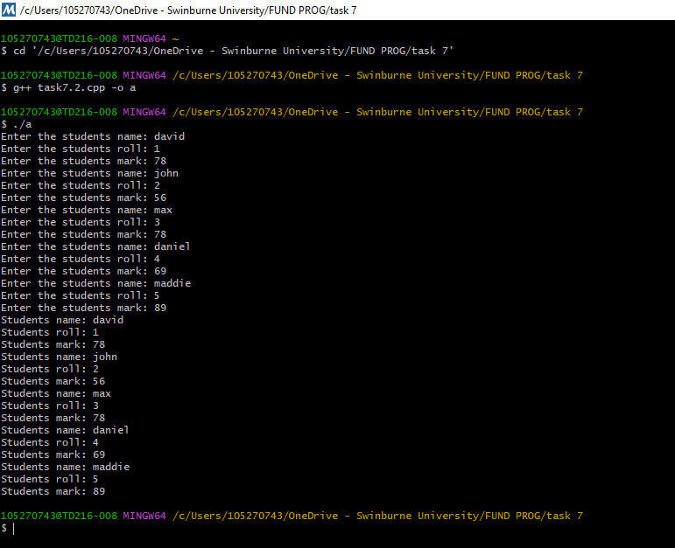
Task 7.3
Code:
#include <iostream>
using namespace std;

struct person
{
string name;
int age;
};

void print_data(person temp)
{
cout << "Name: " << temp.name << endl;
cout << "Age: " << temp.age << endl;
}
int main()
{
struct person p;

cout << "Enter a name: ";
cin >> p.name;
cout << "Enter an age: ";
cin >> p.age;

print_data(p);

return 0;
}

Output:
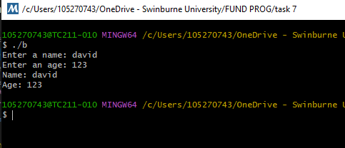
Task 7.4
Code:
#include <iostream>
using namespace std;

#define SIZE1 3
#define SIZE2 2

struct employee
{
string name;
int emp_id;
float salary;
};

employee read_employee()
{
employee temp;
cout <<"Enter employee name: ";
cin >> temp.name;
cout <<"Enter employee id: ";
cin >> temp.emp_id;
cout << "Enter salary: ";
cin >> temp.salary;
return temp;
}

void print_employee(employee emp)
{
cout << emp.name <<" (" <<emp.emp_id << "): "<<emp.salary;
if(emp.salary<4000)
cout <<"Level A\n";
else
cout <<"Level B\n";
}

float employee_total_salary(employee array[], int size)
{
float total = 0;
for(int i=0; i<size; i++)
{
total += array[i].salary;
}
return total;
}

int employee_index_search(employee array[], int id, int size)
{
for (int i=0; i<size; i++)
{
if(array[i].emp_id==id)
return i;
}
return -1;
}

int main()
{
employee test_array1[SIZE1];
employee test_array2[SIZE2];
int i;

cout <<"---Enter array 1 Employee Data---\n";
for(i=0; i<SIZE1; i++)
{
test_array1[i] = read_employee();
}

cout <<"---Enter array 2 Employee Data---\n";
for(i=0; i<SIZE2; i++)
{
test_array2[i] = read_employee();
}

cout <<"---Test Array 1---\n";
for(i=0; i<SIZE1; i++)
{
print_employee(test_array1[i]);
}
cout <<"The total salary of array 1 is: " <<employee_total_salary(test_array1, SIZE1)<<endl;

cout <<"---Test Array 2---\n";
for(i=0; i<SIZE2; i++)
{
print_employee(test_array2[i]);
}

cout <<"The total salary of array 2 is: " <<employee_total_salary(test_array2, SIZE2)<<endl;

i = employee_index_search(test_array1, 123, SIZE1);

if(i!=-1)
{
print_employee(test_array1[i]);
}
else
{
cout <<"Array 1 does not contain an employee with id 123\n";
}
return 0;
}

Output:
